# **CSSE1001: 2017 S2 exam answers**

[**UQAttic**](http://uqattic.net/)

**Get more out of your study time. Join UQAttic's Semester 1, 2012 revision chat.**

[**Other exam papers**](https://docs.google.com/folder/d/0B_gnBD5zp3rqT2hrLWhvd2Rkc1U/edit)

**Read this page first!**

Please **contribute** to these documents.

If you're looking for an effective way to familiarise yourself with the course material, you can't go past collaborating with fellow students. We have laboured to put these up, and so at the very least point out where you think we are wrong!

You'll get more out of the course, you'll do better in the exam, and other students will benefit from your input as well.

**Style.**

If you're unsure of your answer, highlight your answer text then hit Ctrl+Alt+M to create a comment beside the text. Once you're satisfied with the answer, click the "Resolve" button on the comment.

If you want some extra explanation from someone else on their answer, highlight the other person's answer and repeat the procedure above.

If you are confident that your answer is correct, then just type it in red below each question.

**Communicate.**

Head over to [uqattic.net](http://uqattic.net/) and click "Chat Now!". You'll find a chatroom full of students just like you. Talk about a revision document (like this one) or swap prep tips.

If you have your own IRC client, point it to irc.uqattic.net, port 6667, channel #attic.

You can disable automatic email alerts of comment discussions via the "Discussions" button.

Feel free to contribute, unsure about highlighted answers

1. C

2. C

3. A

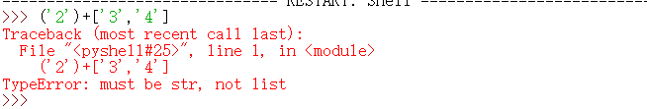why it isn’t e? Cuz it is a list(‘2’)

>>> ['2']+['3','4']

['2', '3', '4']

Thx! T h a n k y o u

List allow +/- i dont think list allow minus

4. E

5. E

6. A

7. C Why is it C, where does the -8 come in? -8 would be a, cause -1 is the last letter, and it’s just counting backwards.

8. E (a and c are *both* valid) Why are a and c invalid and how is E right? A is valid.

9. a whichever what do the 3 numbers mean inside the square brackets?? y=a[x:y:z]

Z is the step of jumping(picking) starting for x to y o ty ;

10. B Can someone please explain this? (change the value of y[:] does not change y itself)Thx bro! (aha! thanx),

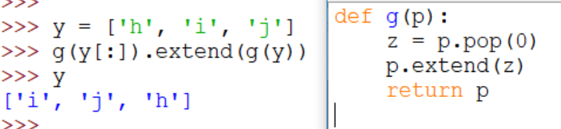

I dont think its B either, how can it be if its a list with 3 items .extend another 3? The list being extended is not *itself* y, but a copy of y, whereas in 11 is is the actual list y that is returned by g().

This still makes no sense to me, its a function being called which returns a list, then appends another list to that list with the same function call?.... ahhhhhhhhh what is happening

B is right , the question is what is ‘y’ value, follow the code, ‘y’ will be replaced by [‘i’, ‘j’, ‘h’],

Why is not a? Are they not the same? (No because lists are mutable so the function will change y when it’s called g(y) but not when it called g(y[:]))

11. C . Why? The extension is made from a copy of the already altered y [‘i’,’j’,’h’], so when the function is performed it pops ‘i’ and adds it to the end -> [‘j’,’h’,’i’] then this is the extension on the original altered y -> [‘i’,’j’,’h’] + [‘i’,’j’,’h’]

12. A can anyone explain this?? IF this is correct: then y.pop(2) = 6, and removes 6 from y. So when you do y.insert(3,6), it inserts 6 into the 3rd index which is after 7. So you get y = [4,5,7,6]. But the question doesn’t actually ask for “the value of y” it just says “what is the value”...? Should this be E? When I put this into IDLE nothing comes out. I also think is E.

13. B can anyone explain this?? This is just the way str.join() works. If I type in help(str.join) in IDLE this is what comes up: The string whose method is called is inserted in between each given string.

The result is returned as a new string.

Example: '.'.join(['ab', 'pq', 'rs']) -> 'ab.pq.rs'

Which is basically exactly what happens here (I didn’t know either..)   
z.split() is making the string into a list, using the space as a divider

.join() takes items and puts them into ONE list ***into one string

14. B f(1,a) doesn't change the value in a? Or it’s only reading the id of a?

Because “a=[1]+a” != “ a.extend([1])” 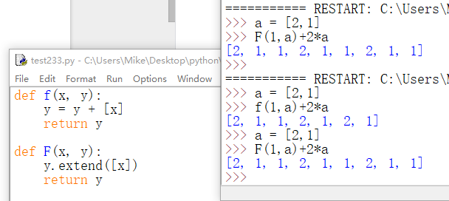

Make sense; ty

15. B What is the difference between { } and [ ] ?????????????? Dictionary and list

16. B there is no Mary so why isnt this an error?? Here is why: <http://bfy.tw/KkqN> ahah okay thanks

17. C how come this returns None? Don’t quite understand I feel so retarded. Thank you, makes perfect sense i think it is because .append does not return anything to x. But d gets the ‘toothbrush’ in its index though.

Coz ‘append’ method has no return, thus x is none.

18. D

19. D

20. E the answer is A): look at indentation. The methods are not part of the class. Have a look at the explanation on the picture below.

This code doesn’t follow the question ^

fred = GoCard(‘Freddy Fred’) was not in the question, so no instance of GoCard has been created in the actual question. So you can’t then call get_balance and parse fred since no fred instance exists.

This is what happened to me with the same code

Traceback (most recent call last):

File "<pyshell#153>", line 1, in <module>

update_balance(fred,-1.5)

NameError: name 'update_balance' is not defined

Answer is E. Fred hasn’t been defined (not set as an instance of the class):

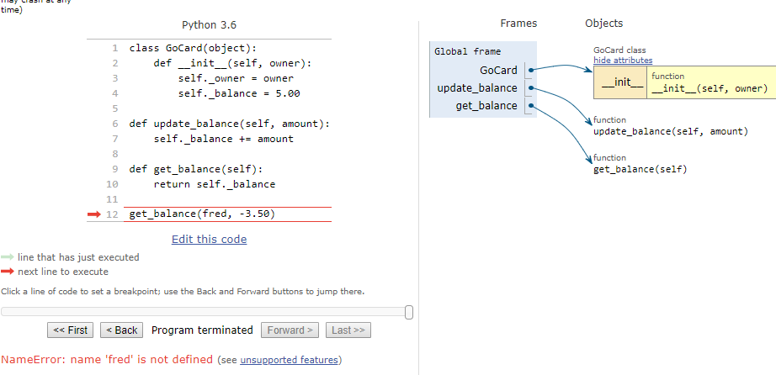

A is wrong

Reason why E for 20:

a: Is a function call with 2 params. We want a method of the gocard class

b: too many arguments given. Python automatically gives in self.

c: correct notation however this will add $3.50 to the balance

d: same as b.

Valid code to take away $3.50 from the amount: [If it was in the class]

fred.update_balance(-3.50)

GoCard.update_balance(fred, -3.50)

21 e

22 b How is this b????? x = (4,3) so a = 4 and b = 3, so a > b: *output is if* *case* (b, a*a + b*b) = (3, 25) which is option B

23 a How? Because you do m(1,2) inside m()first and you will get m(1,5) inside another m() so m(1,5) is the final step of doing this since 1<5, the answer is (1, 5*5+1*1) which is (1,26)

24 b pass processes the for loop as normal. Continue would move to the next item in the loop, which would ignore other code for that item (not that there is any)

Where is 24? Break stops the entire loop/function

What is 24? Pass or continue? I’m thinkin pass, thats all we’ve used lol

Is 24 b?

I think it’s “continue”

I think so.

24. line 1 As per the comment we want to skip that line because it is a blank line so the answer is (b), we can use pass because it's an if/elif so meeting this condition means it also won't reach the others. Alternatively continue is also valid. (from tutor)

25 c because [:-1] will start at the very end and get everything behind it, but [1] will start at the second letter rather than the first pretty sure it is c, as the Pe 0th value will be the ‘[‘, so you want to exclude that. Additionally, .strip returns a list, in this case with only 2 elements, but we only want the first (0th), so you need to specify the [0] index as well. RT Answer should be C

26 a isn’t it a? D is setting the second value as the key...it is A - major_value is the dict{} -> create a key which is minor[0].strip() then assign a variable value for the dictkey minor[1].strip(). #.strip() used to strip() whitespace.

27 c

28 b

29 c why is C? I calculate “l, m, o, m” , i = -5 at the fourth round , then end the while loop. i = 1 after first round, i = -1 after second round, ends while loop.

30 d

31 d - Any explanation for this answer?

b.f(3)

b = B(1) so it becomes:

B(1).f(3)

You look in class B for the function f(x), it is in there so you do B.f(3) = 3*3 = 9

32 d

33 a

34 c **how do you get 8??? Please help! Do you still need help? （I need some help as well） put c1(2,4) in class b, then we know self x=2 y=g=3 2+2*3=8. If you still need help: self.x refers to the class you have called i.e. C1 so it’s 2 and y refers to the value given so 3. But you are also inheriting from B so you use that method to calculate your answer. This is how I thought about it. Not sure if it’s flawed reasoning because only just started programming.**

**c1.g(3) and c1=C1(2,4) thus it becomes:**

**C1(2,4).g(3)**

**In C1 __init__(x,y) you assign y but no x, x is assigned in B.__init__(x), thus in B self.x = 2**

**Thus B.g(3) = self.x + 2*y = 2 + 2*3 = 8**

**But there is no g method in C1, so wouldn’t you go back up to B? I got 7 as my answer (b).**

**Hi**

, 35 C should be C returns 12. +1 +1 - defs should be C 2+2+2*4=8 Must be C 2+2+2*4=12 C

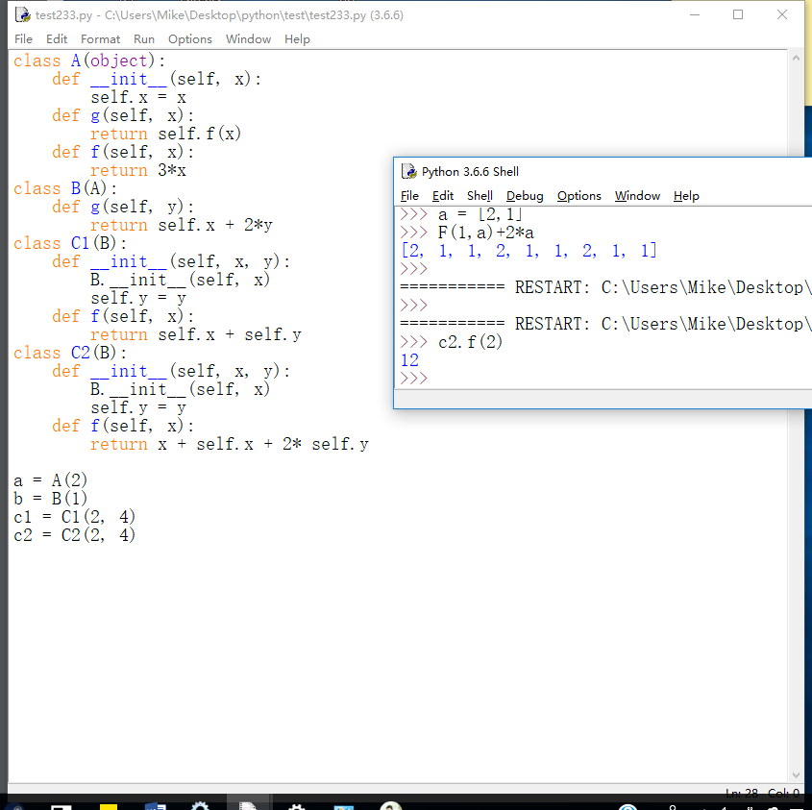

36 d

37 a

38 c

39 b[+1] I think it is d. With d y=546u would be sending off nested[0], which will give the first element, and then still sending [1, 0] as the indexes. This gives the wrong item to work with further. I think its b. You know you guys can just run this in a console to check right?

40 c (can someone explain the process of this) thanks!

It’s list comprehension using anonymous functions lambda.

List is [0,1,2]. x(u,v) is initiated for every u and again for every v.

[Step through](http://pythontutor.com/visualize.html#code=x%20%3D%20lambda%20u,v%3A%20%28u*v%29%0Ay%20%3D%20lambda%20u,v%3A%20u-v%0Aug%20%3D%20%5B0,%201,%202%5D%0Az%20%3D%20%5Bx%28u,v%29%20for%20u%20in%20ug%20for%20v%20in%20ug%20if%20y%28u,v%29%5D%20&cumulative=false&curInstr=64&heapPrimitives=nevernest&mode=display&origin=opt-frontend.js&py=3&rawInputLstJSON=%5B%5D&textReferences=false)

Cheers!

that's a typo in a question should be “what the value of z” -> I **thought this answer was A instead of C. is the answer d or c? Coz there is no ‘y’**

**Answer is C,**

**according to the determining code ‘if y(u,v)’, if y(u,v)==0, then nothing would happen.**

**Thus, y(u,v)!=0: x(u,v)**

**The situations are (0,1), (0,2), (1,0), (1,2), (2,0), (2,1) {in order because of ‘for’}**

**Results are 0*1=0, 0*2=0, 1*0=0 …….**